In this lesson we are going to talk about platform in React native what we are going to talk about platform. First of all Teacher will tell that what is platform because chances are many of you might not know about it what it is and then we will see how to check it and why do we need to check it

If we have to apply condition on the basis of platform inside code how to apply it and there are some more important options inside Platform module we are going to check it so first question is what do we mean by platform it means inside your mobile what OS you are using that is Android or IOS there are mainly three platforms we use that is Android , Windows and IOS windows is very less in use but still there is option of windows that Teacher will tells us Now how to check it. It is a secondary question but one more question will come here that is why to check it why it is required See many times it happens that you write according to different times

1:00

According to android mobile it should be different and different according to IOS and according to windows different and mostly we do it according to UI because resolution of Android and Ios could be different so you might want to take different styles for it but sometimes we have to write something logically differently for example if you have booked Ola or Uber in Android or IOS then check that if you book cab from same place for place then price could be slight different. In Android the price could be slightly less and IOS the price could be more. So how does it do it, they check that which platform is in this application . If he has Ios then he could afford two or three rupees and they show price by making it slightly high it usually happens and there are other things in which you could apply condition so this actually becomes use of it. Now how to check it Teacher will tell it in the code.

In upcoming lesson we will study about redux or a project To use this platform specific login we need to use platform component from react-native which is Platform

So we import it as shown below



Now suppose you need to check what is the OS of your device

So we write a text component inside our view component and then inside Text use jsx bracket and then write Platform.OS as shown in the code below

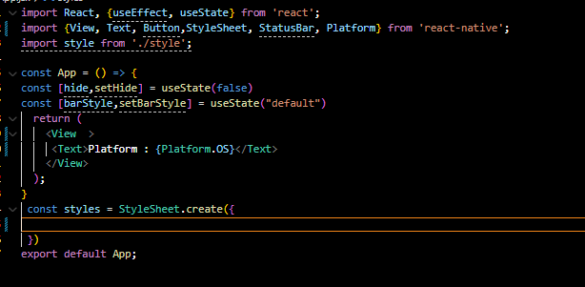

Now our output look like below

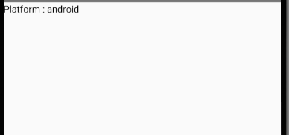

It is showing android because we are using an Android emulator if you were using IOS simulator we call IOS emulator a simulator (who knows) then instead of Android IOS would have been written Now how we will apply condition we checked it what type of phone we have and if we want to add condition then how we add that condition so Teacher is going to add condition on two places one is in design code and another is style code

Now suppose we have add a View and set its height to 100 and width of 100 and set its background color to red now our code look like below

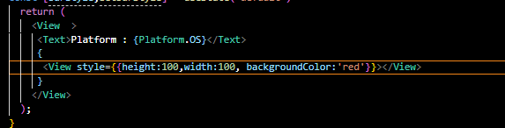

Now our output look like below

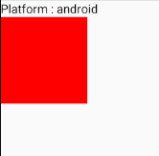

Now suppose we want that in IOS this box should look green in Android and red in IOS so how you do it So inside out jsx code we check is Platform.OS is equal to ‘android’ then show green and else red color So our code look like below

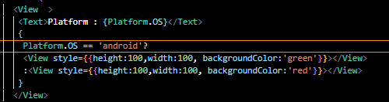

Now our output look like below

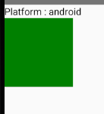

Since we are in android

Now suppose you want that style should be different according to platforms suppose we add a text inside the View after conditional view we added and we write Hello inside the Text and apply style that is internal in nature by a key text and inside its value we added a conditional expression to color such that is it is Android then it will be orange color and otherwise it will be blue in color

We laso increase font size in text property of styles

Now our emulator is android in nature so the text color will be orange in nature

Now our code look like below

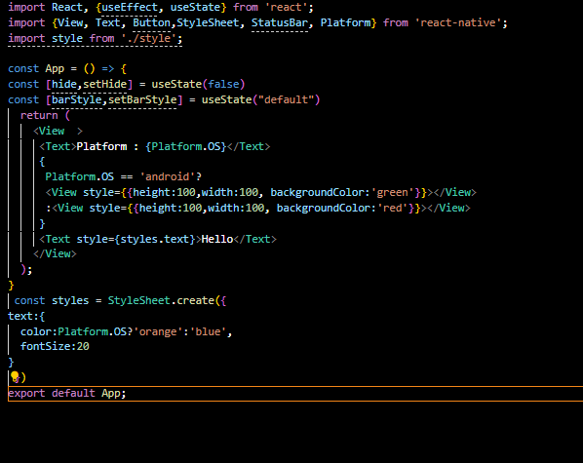

Now our output below

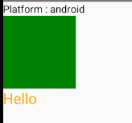

If our platform was IOS then our blue text color would have been blue. Like you have checked conditions for android you can also check it for IOS and windows. Teacher has said preciously there are other properties as well. Lik if you want ocheck react native version then how you will do it

Now to show all the option inside platform on the basis of which you can apply conditions Take a text component and in between paas the stringify function and stringify Platform object Now our code look like below

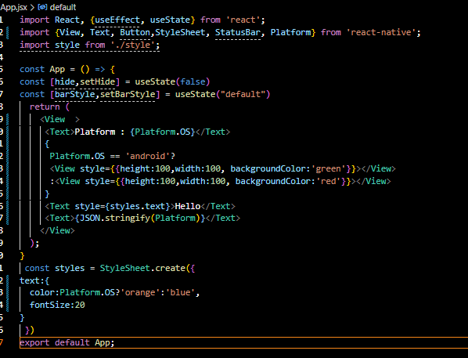

Now our output look like below

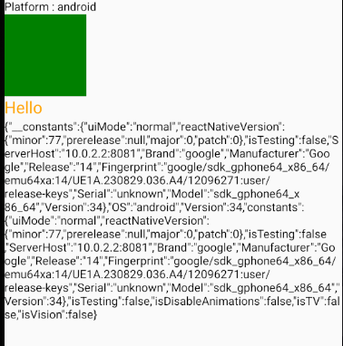

**Note:-**

I think stringify convert the code inside any object or array into an HTML or XML string(who knows)

Now you can see there are so many different option To see it clearly we increase the text component font size containing it

Now suppose you want to find react native version

Now seeing the above structure we know we can do this by Platform.contants.reactNativeVersion

Now we modify our coed such that it shows what is inside it so our code now look like below

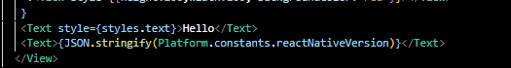

Now our output will be like below

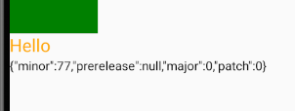

Now there are also option inside it like react native major version is 0 we can show minor

**what is this minor, prerelease, path and major version of react native(short and simple)**

Bhai ye sab **versioning system (Semantic Versioning / SemVer)** ke parts hote hain.  
React Native (ya kisi bhi software library) ka version aise likha hota hai:

👉 **MAJOR.MINOR.PATCH-PRERELEASE**

Example: 0.74.5-alpha

**🔹 Short & Simple:**

* **Major** → Bade changes, backward compatibility break ho sakti hai. (e.g. 0 → 1)
* **Minor** → Naye features add hote hain, purana code phir bhi kaam karta hai. (e.g. 0.73 → 0.74)
* **Patch** → Sirf bug fixes, chhoti improvements. (e.g. 0.74.4 → 0.74.5)
* **Pre-release** → Test version (alpha, beta, rc) jo stable release se pehle aata hai. (e.g. 0.74.0-beta.1)

⚡In short:

* **Major** = big changes
* **Minor** = new features
* **Patch** = bug fixes
* **Pre-release** = testing version before final release

Kya tumhe chahiye ki main React Native ke **current latest stable version** ka breakdown bata du?

so it is made according to the reference of previous version?(onliner)

Haan 👍 React Native ka **next version hamesha previous version ko base karke hi banta hai**, bas changes (major/minor/patch) add kiye jaate hain.

**matlab agar boht major changes hote hain toh 0 se 1 ban jaayega?**

Bilkul 👌  
Agar **bohot bade changes** aayenge jo purane code ke saath compatible **nahi** honge, toh version **0 → 1** (ya 1 → 2) jump kar jaayega.

👉 Yehi **Major version change** hota hai.

Now we want to show major since there is no major major is still 0 we show minor

8:49

Now our code look like below

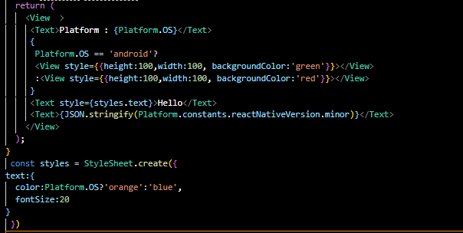

Now our output look like below

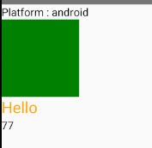

Now you can see the minor that is 77. So by this you can check the version and there are many things which directly if you check constant property inside Platform or even Platform you will see many things you can see things related to testing , who is manufacturer and what OS device has and many things you can check all these things. In interview question they may ask How to apply android condition and IOS question and How you can check react native version It is very important to apply those condition because whenever you make application then there is huge chances that you need to perform something logical on the basis of platform or for UI or style you need to apply condition. See you in the next lesson.